
ame here]

Meet Apollo by Biblionix
Your On-Line
Account

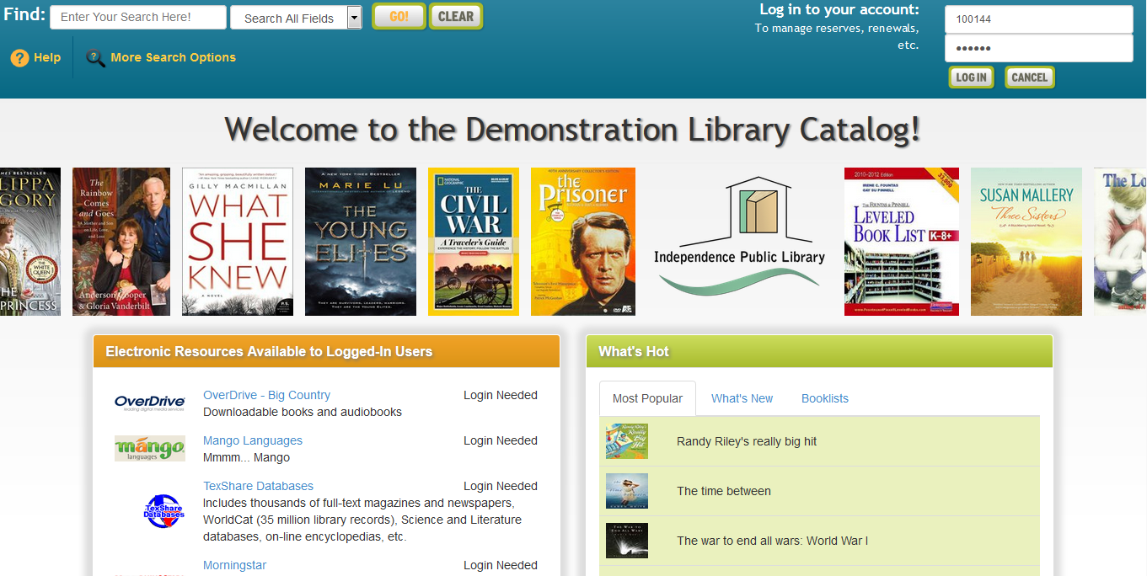
Your Cascade Public Library Catalog has many convenient and powerful ways for you to access information. The on-line catalog is available for your use from any Internet capable device in the library, at home, or anywhere. There are two primary capabilities: Searching for a book, a DVD, etc., and managing your library account. This document covers instructions and tips on how to get the most out of your library account. If you need help, please don’t hesitate to ask a staff member for assistance.

Overview:
The catalog maintains an account for each member.
The many features and functions are available including:

- view items checked out and their status
- renew items
- reserve items
- balance due (for lost, unreturned, or damaged items)
- delay your reserves so you won’t miss your turn

Let’s take a quick tour of your “My Account”.

Logging In:

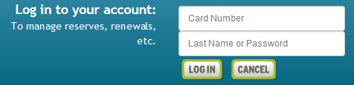
To log-in to your account, enter your “Card Number” and phone number or password into the fields in the upper right corner of the catalog welcome/search page. Enter your phone number (without the dash). If it has the same area code as the library, you do not need to enter it. Select the 'Log In' button.

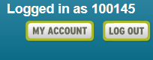
Click “My Account” button -

Let’s look at each section of My Account.

Account Info
Here you will find your name, address, phone numbers, email address, etc. If you have moved recently, please drop by the library to make the address change.

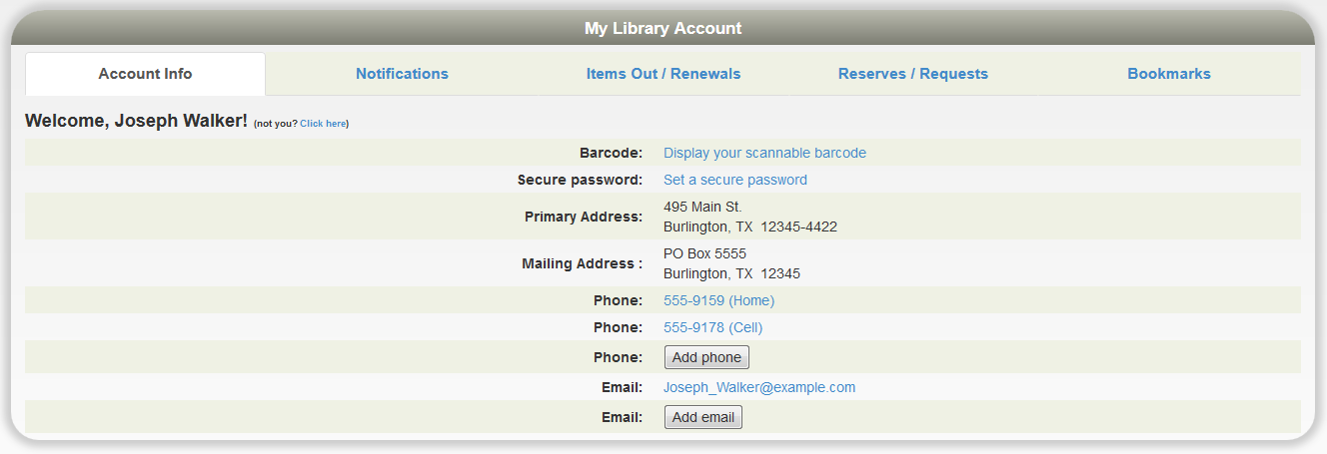

Notification Options:
The library will notify you of various situations using the contact method selected in this section. To change an option, click the drop down box. The choices are derived from your “Account Info” in the first tab. The feature “3 day Notice Before Items Are Due” is only available through text message and email, otherwise you may choose the options phone call, text message, or e-mail.

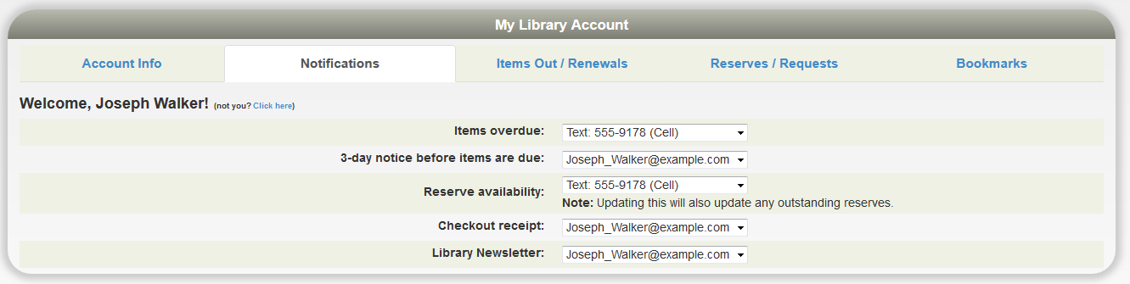

Items Out, Renewals
This next section shows all items currently checked out to your account. You’ll see the title, due date, and etc. If a renew button is shown to the right of the due date, you can just click on it to renew the item. The item might show “Not Renewable”. This might be for a number of reasons: If it is on reserve by someone else, or that type of item (e.g. DVD) is not renewable, or you have fines over the limit, or your card has expired.

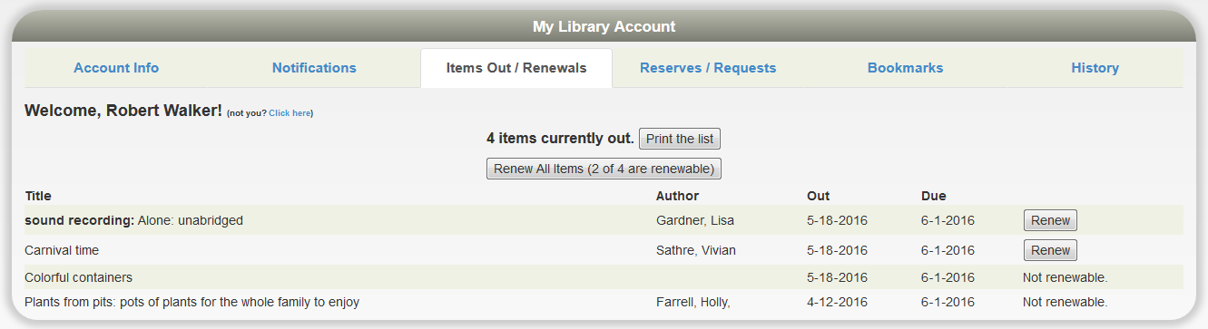

Reserves/Requests

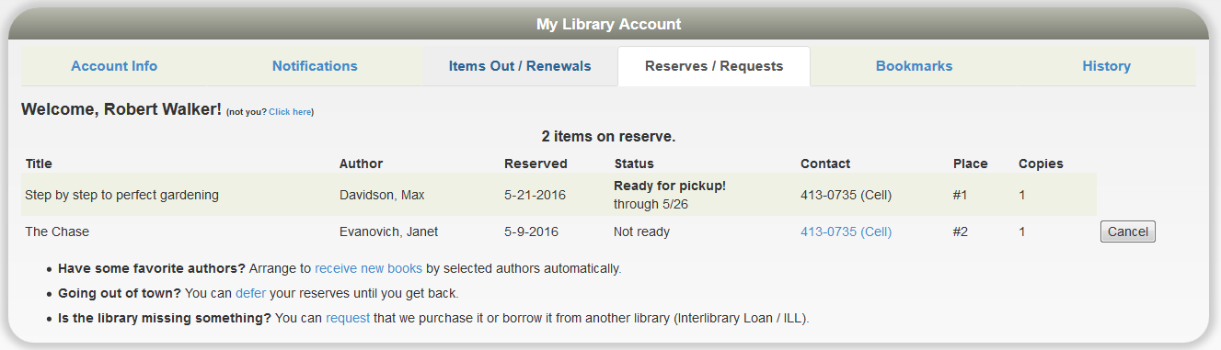

This section lists any reserves you have placed and it typically notes your place on the reserve waiting list. It also shows how you elected to be notified. The “Copies” column indicates how many copies the library has of that title. Note that you can cancel the reservation on items that are not ready.

Going Out Of Town? – You can avoid losing your place in any reserve line by indicating when you will not be available. If your turn comes up during any of these times, you simply move one place down in line. You’ll get that favorite item you’ve been waiting for without going to the end of the line. To indicate when you're unavailable, click “defer” and you’ll see a calendar pop-up. Click any date to mark it is an unavailable. It will turn blue. Click again to mark it is as available. It will return to white. You can move to different months as necessary with the arrows in the top left and right. You can also click/hold across days or weeks to mark a date range.

Is The Library Missing Something? Place a request for an item here and this will inform the library staff of your request.

Bookmarks

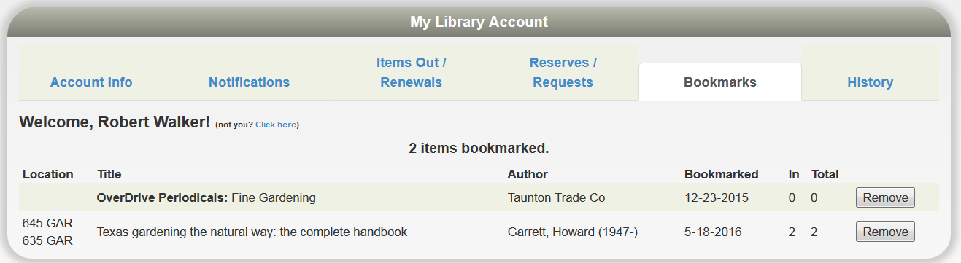

The bookmark section is for your convenience. The library does nothing with your list. This feature could be very useful when doing research and a bibliographic reference will be needed. You may wish to use bookmarks as a reminder of things you want to read in the future or have read in the past. When you are logged-in to the Public Catalog, and view individual records, you can simply click the, “Bookmark This Item” button. To remove a bookmark, click the “Remove” button found at the end of a book marked title in your account.

History

Depending on your library’s configuration choices as well as your own, you can see what you have checked out in the past (this listing does not currently include e-items). Check with your library if want to change you option for this.

You can search this list by using Ctrl-F in your browser (or similar ‘search’ option on a phone or tablet). Also you can export the whole list as an Excel spreadsheet.

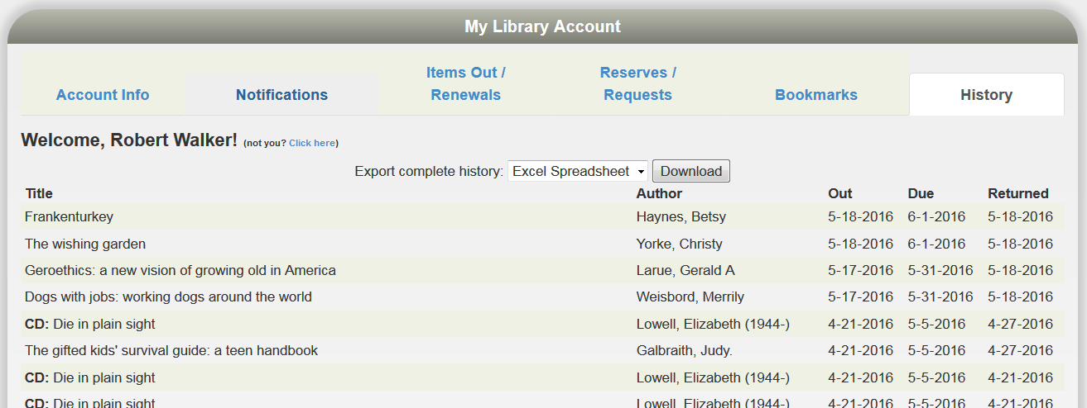

Note that if you are logged-in and searching for an item, Apollo will tell you if you have checked it out. You do not have to refer to the list above. Here’s an example:

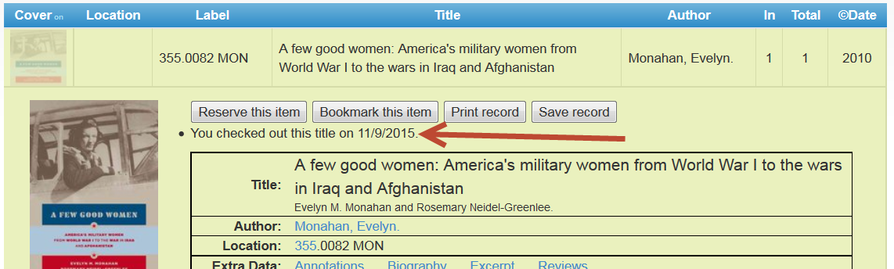

We hope you enjoy these capabilities. Let us know what you think.

