

Apollo by Biblionix
Our On-Line
Library Catalog

The Cascade Public Library on-line catalog is available for your use from any Internet capable device (computer, phone, tablet, etc.) in the library, at home, or anywhere. There are two primary capabilities: the catalog and your library account. Instructions on the catalog are provided here. Account information can be found in a different document. If you need help, please don’t hesitate to ask a staff member for assistance.
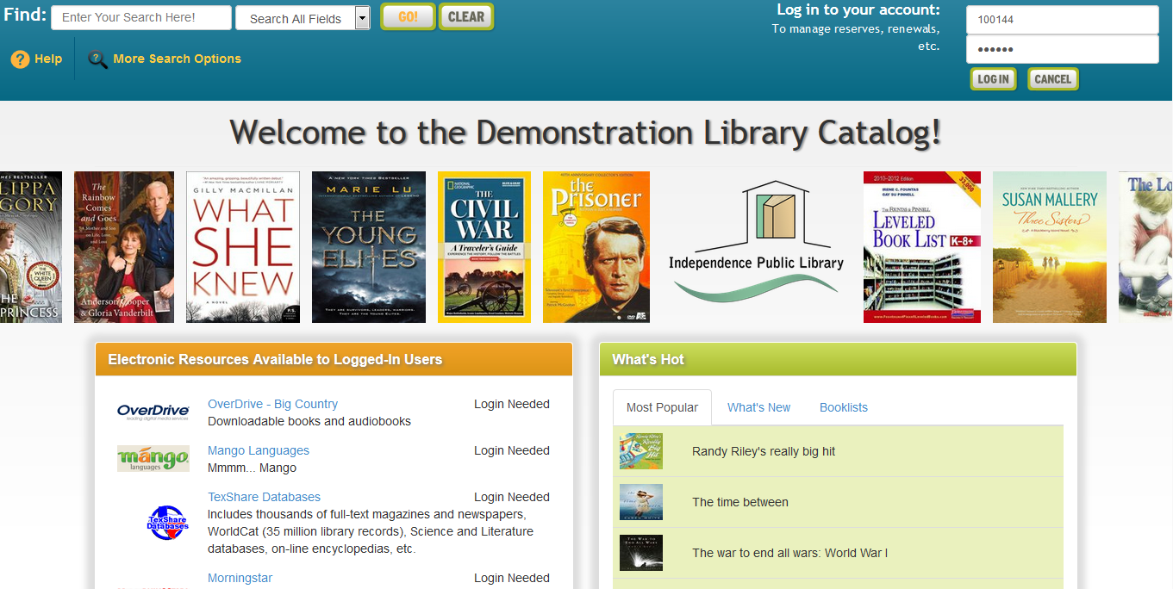
ACCESSING THE CATALOG:

You can access the catalog directly using the catalog URL. It's https://cascadeia.biblionix.com.

SEARCHING:
There are 3 ways of searching: “Search All Fields”, “More Search Options”, and “What’s Hot”. The “Search All Fields” option is what is used when you use the search blank from the library’s homepage.

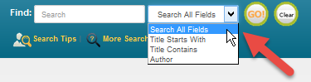
Search All Fields: most likely, you'll want to use this simple search. It performs a Google® type search (including putting phrases in quotes). It searches all titles, subtitles, authors’ first and last names, various notes, and a number of other fields. You'll be presented with the list of titles based on their relevancy to your search. Word order and letter case do not matter. To use this method, simply type a word, words, or phrase, into the blank at the top of the screen. Then either push the Enter key on your keyboard or click the GO! button. Other search options in the drop-down menu are “Title Starts With”, “Title Contains”, and “Author”.

Keyword Search Examples:
  - DVDs based on books by John Grisham: grisham dvd
NOTE: For searches with "AND", "OR", use More Search Options. .
  - The Lord of the Rings series: “lord of the rings”
  - Snakes in Texas: snakes texas
  - Items involving a particular fictitious character: jack ryan
  - That book you heard about once, written by fred sea
somebody named Fred that has "Sea"
somewhere in the title:
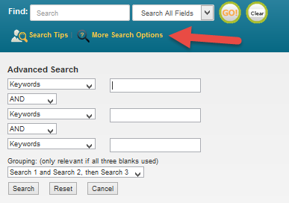
More Search Options:
If you wish to perform very detailed searches this option is for you. It also allows you to examine the subject categories that the library is using

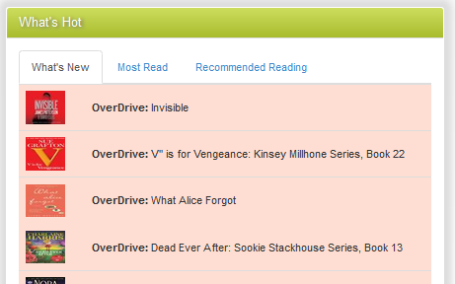
What’s Hot: Have you ever wanted to know what new items are available in the library since the last time you looked? Curious about what items are the most read at your library? Or do you want to see the library’s Recommended Reading list(s)? The “What’s Hot” on the catalog home page will show you.

SEARCH RESULTS
Below is example image of a search result. It shows results for a 3-word search: dogs puppies training. Each line/title is color coded: Green for “In”/available for check out, and Pink for “Out”/not available. The “Label” and/or “Location” column(s) tell you where to locate the item in the library. The “Score” column is the relevancy ranking, with 100 being a 100% match. The “In” column tells you how many copies are available, etc. (Note: if you were to perform another search, your previous search(es) will appear above the current results for fast access. Instead of the “Back” button, use this history listing).

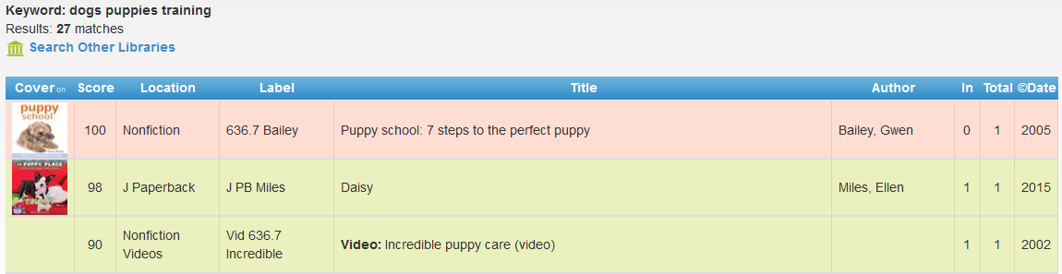

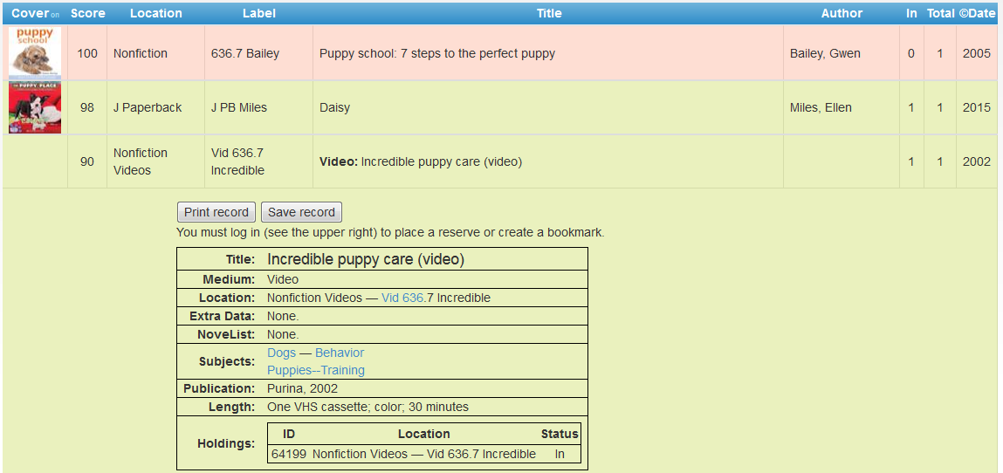
You can:
- Click an item, green or pink, to see more information and to place a reserve on it
- Click on a column heading (Label, Title, Author, and etc) to sort the list by that heading. Click again to sort in the reverse direction.

When you click on an item, the item will expand in the search results list revealing more information. For example, by clicking a subject (eg Puppies) you get a list of additional items we have in that subject.

You can also place a reserve on that item by logging in. When the item becomes available, you will be notified.

We hope you enjoy the catalog. Let us know what you think.

