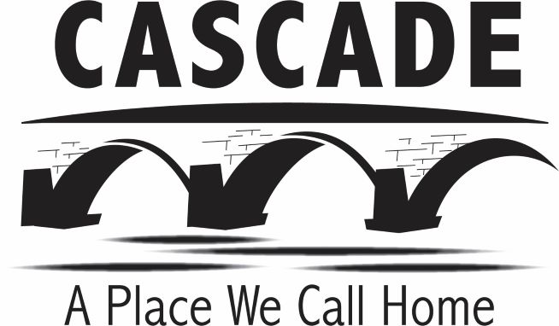
City of Cascade
PO Box 400
Cascade IA, 52033
563.852.3114

CITY OF CASCADE, IOWA
COUNCIL MEETING AGENDA & PUBLIC NOTICE
MONDAY, MARCH 14, 2022, 6:00 P.M.
CITY HALL, 320 1ST AVE WEST

NOTICE: Notice is hereby given Cascade City Council will hold a meeting at 6:00 PM on Monday, March 14, 2022, at Cascade City Hall. Any visually or hearing-impaired person with special accessibility needs should contact the City Clerk at 563-852-3114.
Meetings are live streamed at www.cityofcascade.org under city of Cascade tab and on Local Access Channel 18

- Call to Order
- Pledge of Allegiance
- Roll Call
- Approve Agenda
- Speakers from the Floor (limit 2 minutes per person).
  - S. Keyron McDermott
- Consent Agenda – Review and approve the following:
  - City Council Minutes 2/28/22
  - Library Board Minutes 3/1/22
  - Park Board Minutes 3/7/22
  - CMU Minutes 3/9/22
  - February 2022 Reports and Fund Balances
  - March Claims
  - Cascade Columbus Club Liquor License Renewal
  - Reappoint Greg VanderLugt to Municipal Utilities Board (6Yr Term)

- Resolution No 11-22 Awarding Buchanan St NW Alley Project
- Resolution No 12-22 Approving Amendment to Buchanan St NW Alley Project Contract
- Shop Compressor Replacement
- Pool Pass Rates
- Approve City Administrator Offer of Employment
- Reports – Police Chief and City Administrator
- Adjournment

