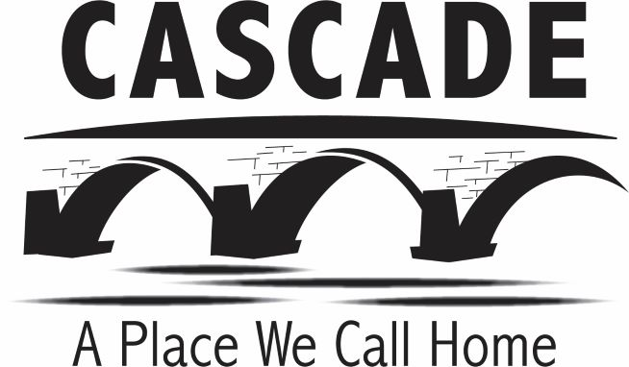

City of Cascade
320 1st Ave W
Cascade, Iowa 52033
Ph. 563-852-3114
cascadecity@netins.net

City of Cascade Personnel Committee Meeting Agenda & Public Notice
Tuesday, June 7, 2022, at 8:00am
Cheryl’s Flour Garden Bakery and Coffee Bar
126 1st Ave W, Cascade, IA

Tentative Agenda:

- Roll Call
- Discuss Personnel Matters -FY 2023 Employee Wages
- Adjourn

