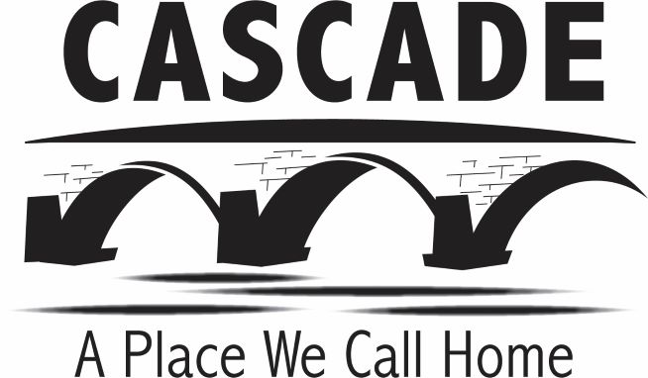
City of Cascade
PO Box 400
Cascade IA, 52033
563.852.3114

CITY OF CASCADE, IOWA
SPECIAL COUNCIL MEETING AGENDA
THURSDAY, MARCH 10, 2022, 4:00 P.M.
CITY HALL, 320 1ST AVE WEST

NOTICE: Notice is hereby given Cascade City Council will hold a Special Meeting at 4:00 PM on Thursday, March 10, 2022 at City Hall.

- Call to Order
- Pledge of Allegiance
- Roll Call
- Approve Agenda
- City Administrator Interviews
Possible Closed Session Iowa Code 21.5(i) To Evaluate Professional Competency of an Individual Whose Appointment, Hiring, Performance is Being Considered
- Adjournment

